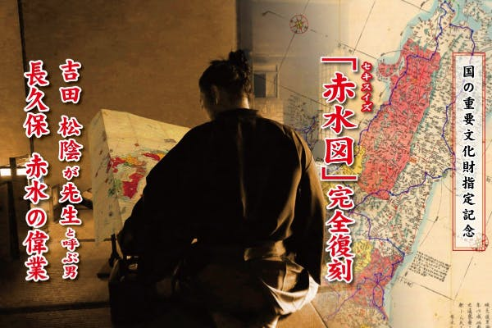

[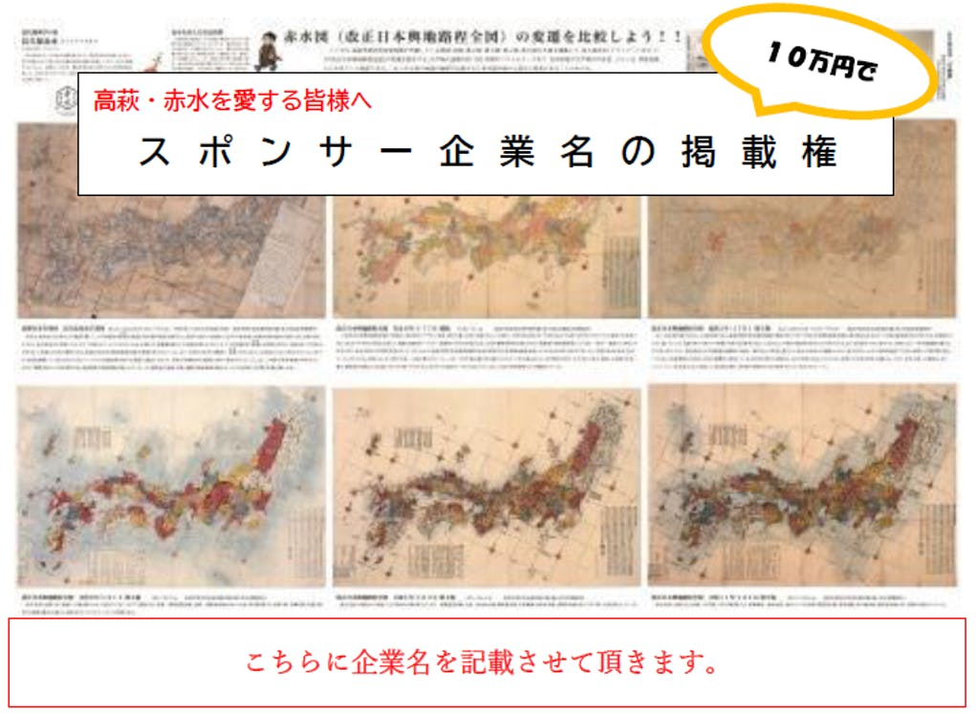](https://camp-fire.jp/projects/249538/backers/new?id=341203)